**Sprint 1 Plan**

**Project: Beads Net**

**Team: Weaver**

**Sprint Completion date: 10/10/2018**

**Goal:**

To make an app that can allow users to find a list of similar movies/animes with ranking in spider-web like form by searching names or clicking on tags. It also let users to get the information of the movies and add tags for specific movies.

**Tasklisting：**

User story 1: As a user, I want to use this app anywhere, no matter at home or outside.

Task 1 - Learn HTML5(8 hours)

Task 2 - Learn Android Studio(4 hours)

Task 3 - Learn JavaScript(8 hours)

Total for user story 1: 24 hours

User story 2: As an anime audience, I want a more convenient anime ranking with vivid image and tables.

Task 1 - Search page design(2 hours)

Task 2 - Main page design(2 hours)

Task 3 - Information page design (2 hours)

Task 4 - Coding for a functionable Main page Layout(8 hours)

Total for user story 2: 14 hours

User story 3: As an anime audience, I want to find the best in my interested field.

Task 1 - Implement Imdb API(1 hour)

Task 2 - Implement keyword searching(3 hours)

Task 3 - create database for save user’s interests(3 hours)

Total for user story 3: 7 hours

User story 4: As an anime audience, after watching a masterpiece, I quite want to see other similar products.

Task 1 - Implement tags to animes/movies/shows(6 hours)

Task 2 - coding for functional webpage(8 hours)

Total for user story 4: 14 hours

**Team Roles:**

Zike Peng, Project Owner (Database)

Jiapei Kuang, Scrum Master (Debugger, UI Developer)

Ge Lu, Developer (UI Developer)

Zidu Chen, Developer(front-end)

Zhiyue Li**,** Developer(front-end)

**Initial Task Assignment:**

Zike Peng: user story 1, initial task 1 (learn HTML5, JavaScript)

Jiapei Kuang: user story 2, initial task (Main Page Design)

Ge Lu: user story 2, initial task 1 (Search Page Design)

Zidu Chen: user story 1, initial task(Learn HTML5, JavaScript)

Zhiyue Li: user story 1, initial task(Learn HTML5, JavaScript)

**Initial Burnup Chart:**

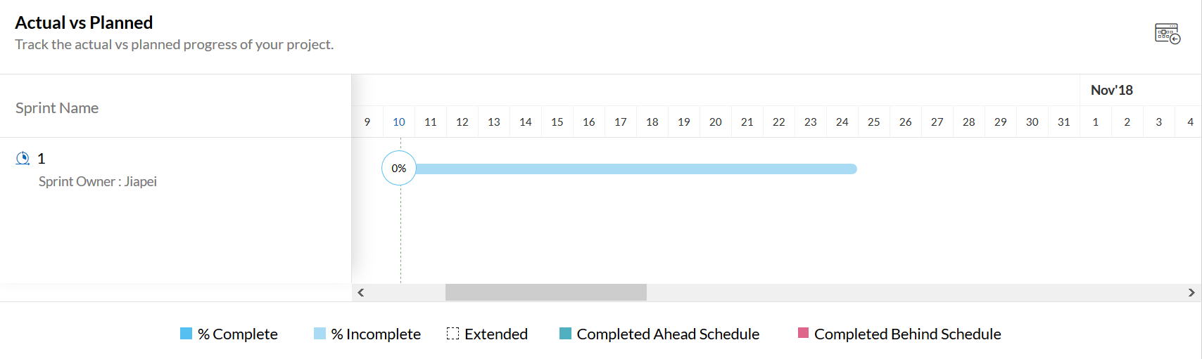

**Initial Scrum Board:**

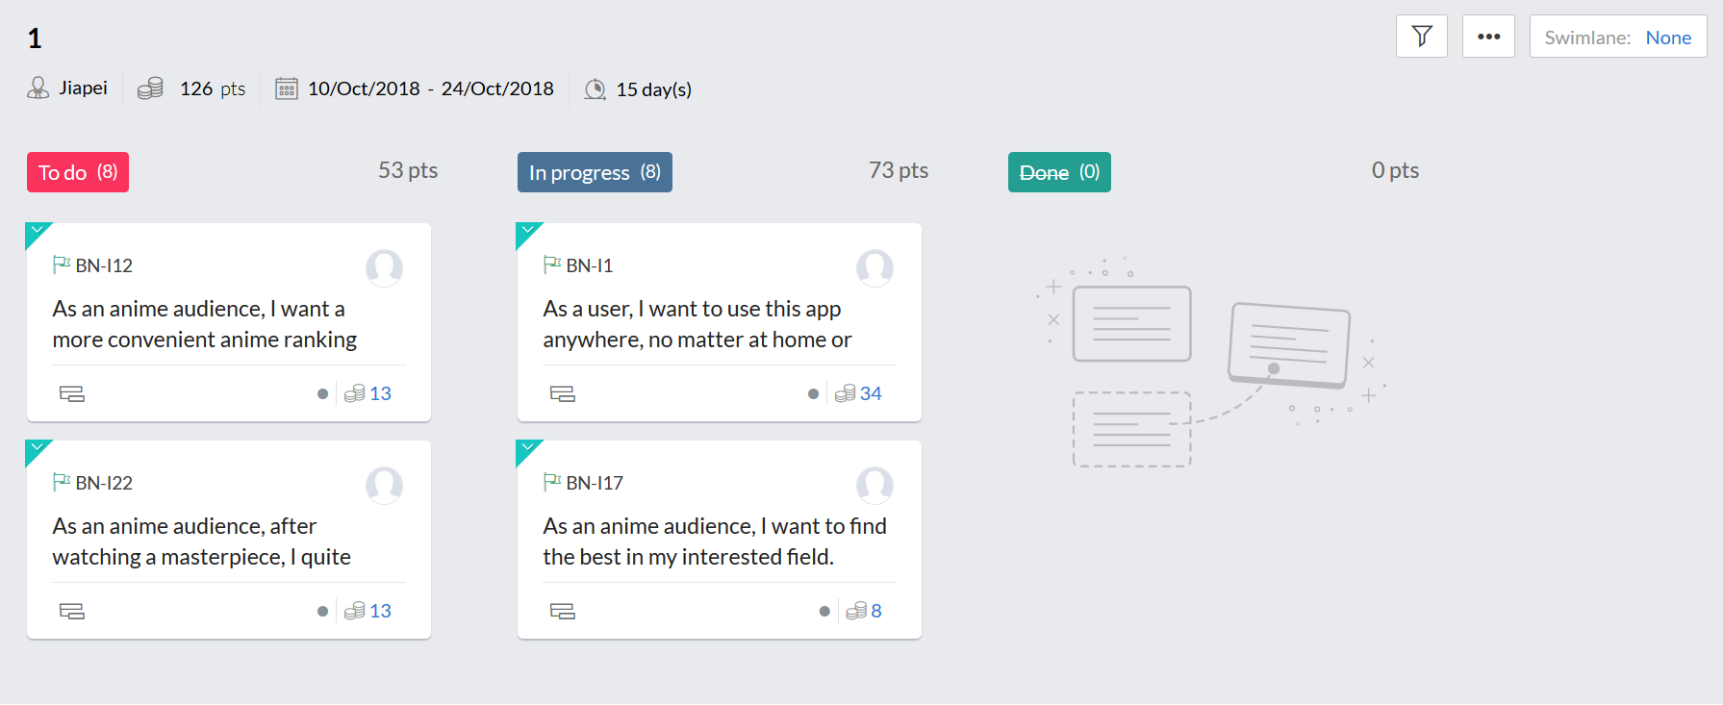

**Scrum Times:**

**Meet with TA:** Tuesday 12:00 pm - 12:30 pm

**Meet without TA:** Thursday 12:00 pm - 1:30 pm